

SCARAB: Design Document
For submission to SETU

Author: Stuart Rossiter
Student Number: C00284845
Course: BSc (Hons.) Software Development
Supervisor: Joseph Kehoe
Contents
1. SCARAB Program 3
2. SCARAB Device 4
2.1 Circuit Diagrams 4
2.1.1 SCARAB Device 4
2.1.2 SNES Module 5
2.1.3 N64 Module 6
2.1.4 GBA Module 7
2.1.5 NES Module 8

SCARAB Program

SCARAB Device

Circuit Diagrams

SCARAB Device
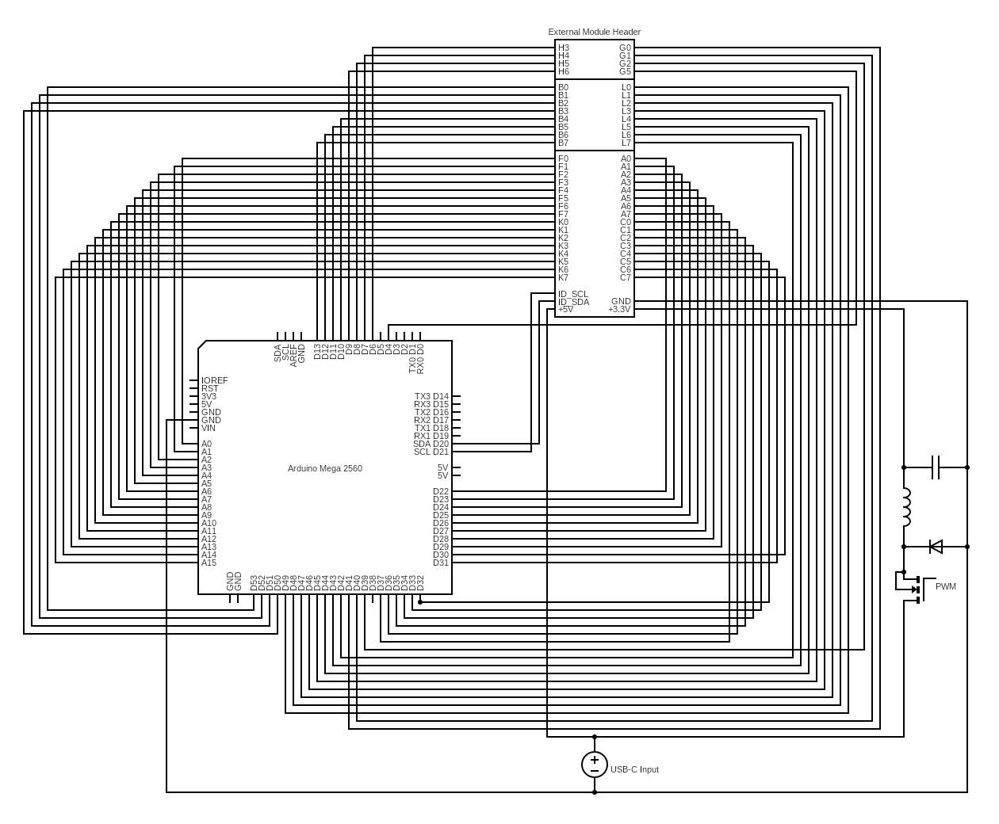

SNES Module
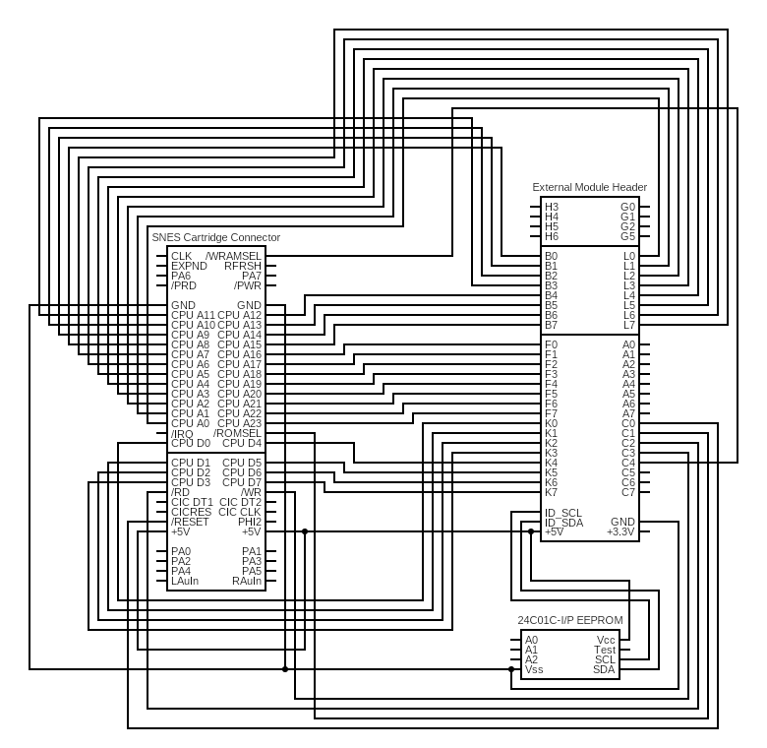

N64 Module
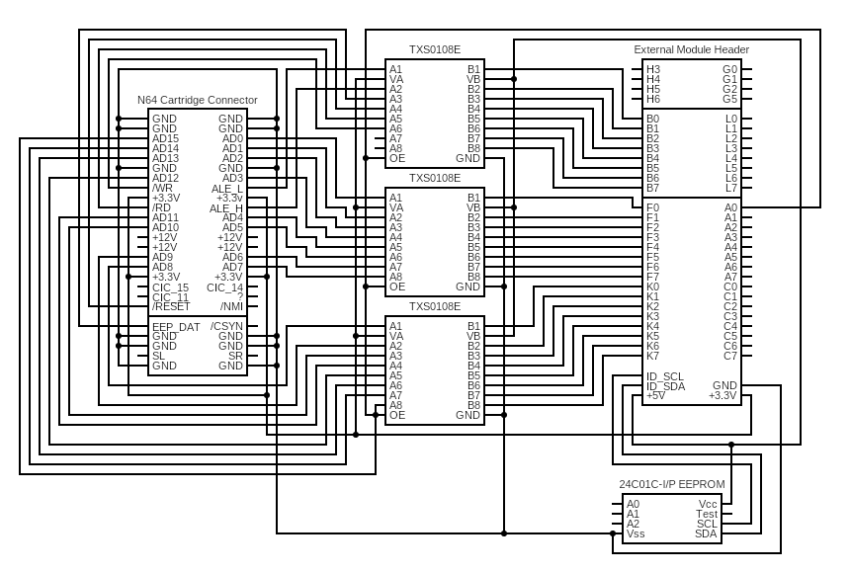

GBA Module
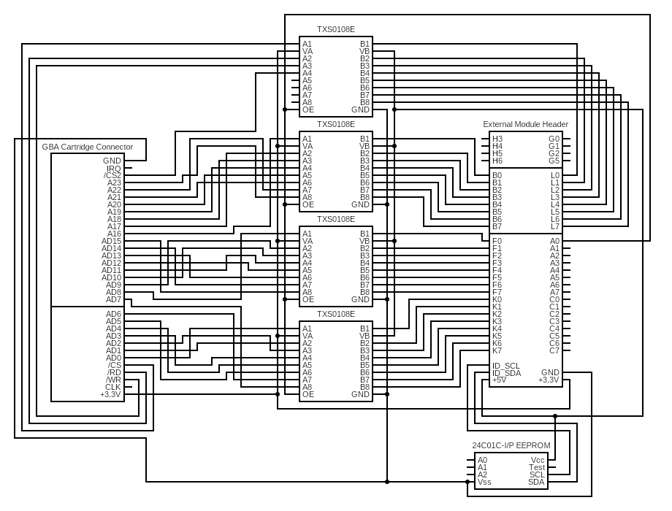

NES Module
